‘With Flaming Zeal’ Lionel Fitzsimons ©1998 Ambassador Publications Belfast

Henry Merriweather
1884 – 1977

Harry Merriweather, as he was always called, is another link person to the present day. His long life began on 16th January 1884. It spanned the lingering death of colonialism, the triumph of nationalisms, and the resurgence of old religions. The first era began before he was born, and was accompanied by great revivals of Evangelical Christianity. Harry himself was powerfully affected by the movement which broke out with renewed power in Wales in 1904. It was a time of clear cut issues and standards.
In North Yorkshire too, religion was a very vital thing. He was brought up on a farm near the large village of Masham. Two generations of his Wesleyan Methodist family had already given missionaries to the Church. "What memories the thought of that Chapel revives! Memories of great local preachers who preached in the power of the Spirit in the vernacular, of praying saints and hearty congregational singing. To this day", he wrote in old age, "the singing of certain hymns takes me back, and I fancy I hear them being sung to the twitter of the sand martins as they darted in and out around the Chapel windows".
It was in the hollow stump of a fallen old elm tree in the cow pasture that the boy sought to imitate the great preachers of those days, using it as his pulpit and preaching "to the surrounding buttercups and daisies!". It was not only the sight and sound of preaching that impressed his young mind, but the after-church prayer meetings, "when the saints came to the Communion rail and poured out their souls to God".
By the time he was sixteen, the family had moved to West Hartlepool. "We had a family pew in what was called 'Big Wesley', a large Methodist Chapel that had been built in faith in the centre of the town. At that time there was much excitement because the great evangelist Gypsy Smith was coming to our Chapel for an evangelistic campaign. The Spirit of the Lord worked, and quite a number of the young men and maidens of the senior Sunday School classes were converted. There was a night when I should have been, but I was too nervous to come down from the gallery where I was sitting, and walk right through the Church to the enquiry room at the other end. Nevertheless an older brother (William) who was converted at that time invited me the following week to a Mission Hall to hear a converted barber speak. This young man was on fire with a passion for souls and when, at the close of his address he made an appeal for any who would like to decide for Christ to come to the front, my brother asked if I wouldn't like to go. I didn't need much encouraging, and accompanying me there he led me to Christ".
The change was real, and he plunged straight into Sunday School teaching and other service. He recalled his first preaching engagement "as if it were yesterday; another fellow who had recently been converted and I were to take the Sunday morning service. I forget my own efforts, but I remember how my friend gave out his text, 'I am the light of the world' and then hopping off one leg on to the other he said it again, then changing his position he repeated it, and then looking into the air he said, 'Friends, I've been preaching it over to the ornaments on the mantelpiece all the morning, but it won't come now, so I'd better sit down!".
Merriweather was never academically inclined, but he had business ability as well as zest for life and great love for people. As a Bible teacher he was vivid rather than profound, but his gifts were outstanding as pastor and even more so as an evangelist. There was a simplicity and directness about his approach to people. He went into commerce first in Chesterfield, then in Manchester briefly, and back to Chesterfield. Everywhere his leisure time was wholly given to service for Christ. At Chesterfield, "Sunday began with a prayer-meeting at 9.30 a.m. followed by a Sunday School in a very tough part of the town, then home 2 miles for lunch, back again at 2 p.m. for another Sunday School session, after which a band of us visited the old people in the Workhouse for a service, then home for tea, then off to one of the many lodging-houses for which Chesterfield was famed, after which there was the evening service followed by a prayer meeting and we finished up by visiting the aged and infirm who were unable to come to Church. What happy days they were!" Strenuous days, too.
In 1906, at the Chesterfield Conference or the deepening of spiritual life, Harry Merriweather was powerfully affected by the message of the main speaker, a leader of the Welsh Revival. Also taking part were some members of the Ceylon and India General Mission, an inter-denominational missionary society.
In the final meeting Merriweather found himself "standing tremblingly... and yielding my life to God to go to India if He could use me".
Obviously he needed more theological and practical experience, so he applied for, and began in September of 1906, a two year course at the Bible Training Institute, Glasgow. At this point, God saw fit to test his faith and obedience dramatically. He felt suddenly constrained to send all his savings to a worthy cause that was brought to his attention, and was left without fees to cover his entry to B.T.I. The following morning, a stranger approached him in the street, greeted him by name, and after enquiring about his needs, offered to pay not only his course fees but his outfit and passage to India too!
With students from Wales, there was a touch of revival at the Institute. Much preaching was done in the streets. It was not always easy to attract a crowd. On one occasion, Merriweather recalled, "A sudden inspiration seized me, and taking the collapsible organ stool to the other side of the street I put my New Testament on it and covered it with my muffler. Then walking around it, every once in a while I would lift up one corner of the muffler and cry, 'Yes friends, it's true, it is there!'. This went on for some minutes and soon the street end was packed, and pulling out my New Testament I told them it was the Word of God that was there, the Word that showed them the way of salvation".
In these years Merriweather developed his interest in and rapport with children and young people by visits to Quarrier's Orphan Homes, Bridge of Weir, and in the Fresh Air Fortnights on the Firth of Clyde for slum children. On one occasion, while he was speaking at Quarrier's, thirty children responded to an appeal for commitment to Christ. One later became Principal of a Bible School in South Africa.
Along with two older C.I.G.M. missionaries and one other recruit, he sailed on 11th November 1908 and began language study of Tamil at Kurichee, in the Tamil Nadu area of South India, of which he became a very good speaker.. After about a year he was given the job of teaching young men to read their own language. Even here "We were anxious that the young converts should have the Word of God hidden in their hearts, so finished up with a time of memorizing Scripture verses and prayer". Merriweather as a single man was highly embarrassed when they began to pray aloud for a wife for him! One even offered to act in Indian style as a go-between in approaching a particular lady missionary who seemed to his eyes suitable! One of the senior missionaries, a Miss Kenny, .who was also a great evangelist. Merriweather had had the joy of seeing several people brought to faith and freedom, including a demon-possessed Hindu priestess. Later he was to led four generations of her family to the Lord. In baptizing such converts, Merriweather became convinced he himself should undergo baptism by immersion.

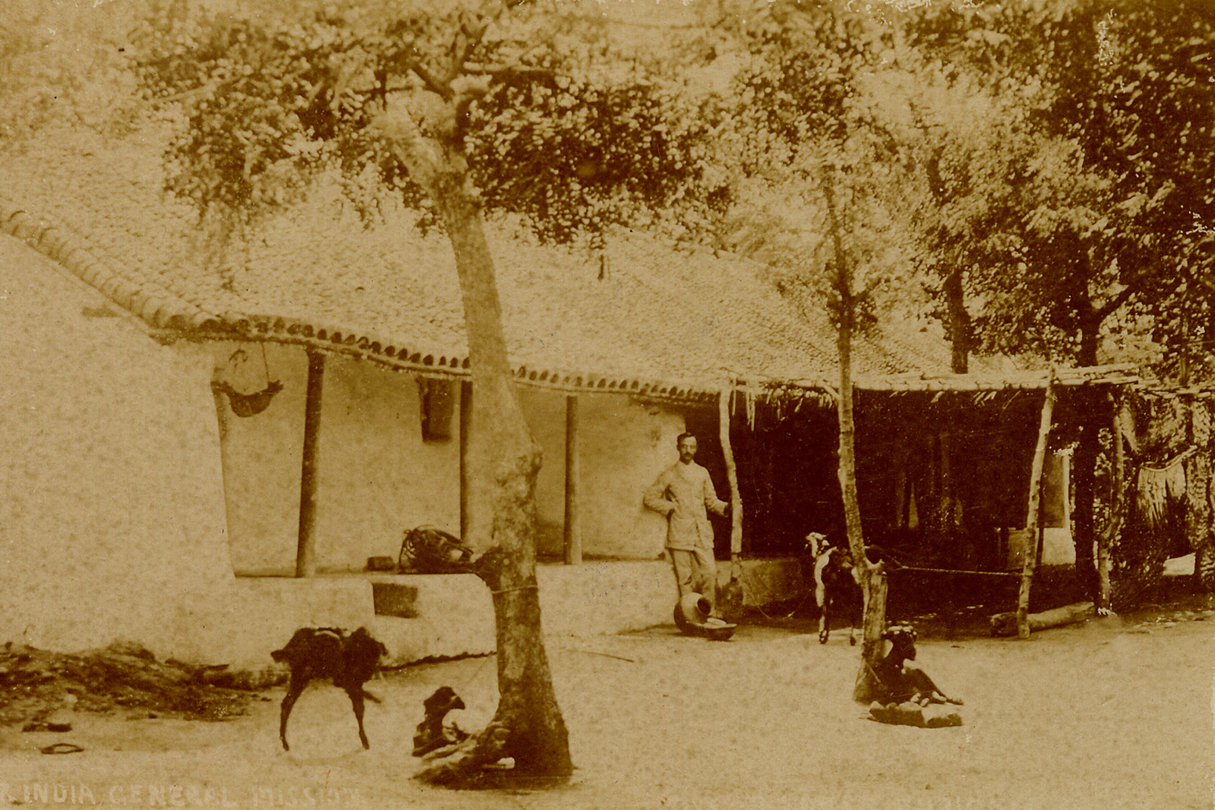
In the following summer, his Indian friends' prayers were answered when at the hill station of Kotagiri he met, and the next year became engaged to, Geraldine Cranmer Beauchamp of the Church of England Zenana Mission. She was nine years older than himself and had been working among Muslim women in Mysore city. Miss Beauchamp had, to say the least, an unusual back-ground for a missionary. Born in wealthy circumstances, she was brought up on her father's estate "Trevince", Gwennap, near Falmouth in Cornwall. In "Our Own Granny's Story", written many years later, he told how she got her middle name. "One of my ancestors had been the good Bishop Cranmer whom the naughty Roman Catholics had burned to death because he wouldn't worship idols"! Her mother dying at the birth of a younger sister, the father re-married. The new stepmother treated Geraldine and her sisters with something less than affection or equality. However, they grew up lively girls, and Geraldine had no psychological scars.
When she was twelve years old, they spent an extended holiday in Ireland with their maternal grandmother’s favorite younger sister, their Aunt Augusta, Lady Gregory. This well known literary hostess numbered among her protégés W. B. Yeats, who wrote his poem on the wild swans at her residence, Coole Park, County Galway.
On his first visit to his prospective wife's family home, it was a matter of both wonder and amusement to the farmer's son, to have his cases unpacked and clothes laid out by the butler, one of a large number of servants.
Good Anglicans of a rather High Church tendency, the sisters were all confirmed as a matter of course, Geraldine when she was fifteen. She felt she had always loved God as best she knew, and remembered vividly the text from which Bishop Speechly spoke at her confirmation, "Speak, Lord, for Thy servant heareth". The local vicar, Canon Rogers, once spoke on Jairus' daughter, and emphasized how Jesus had turned out those who were making a lot of noise. Billy Bray, the little tin miner who led the vigorous and rowdy Non-Conformist witness in that area, later met the Canon and said to him, "1 understand ye do like a peace and quietness? I do love a lot of noise!"
( A quote of Billy Bray’s, “If ye locked me in a barrel, I’d shout Hallelujah! out the bung hole.)
Geraldine's Evangelical faith developed only slowly, and for a long time she had a low opinion of missionaries and their work. This impression she had first gained on a visit to Ceylon, where her sister had married an agent in the tea business.
(Bill. I fear that this is the writer’s opinion. Mother said that at a morning prayer meeting she attended, the leader said, “I am sure if we were asked, we would all say that we would be a missionary.” Mother’s thought was, “I wouldn’t be a frumpy old Missionary, but this started her thinking). However at the Keswick Convention in 1904 she finally surrendered to God's call. In her Bible she had come across the phrase, "ambassadors for Christ". She suddenly realized the honour and responsibility of being called to that by your Country, and how much more so by Christ himself.

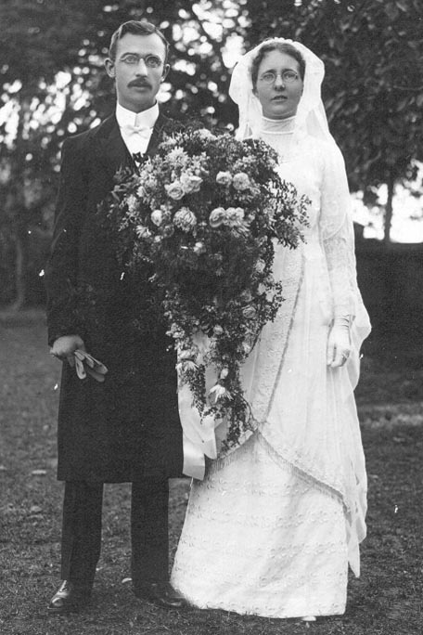
The couple were married in 1913 at St. John's Church, Bangalore, and returned from honeymoon by bullock cart "at two miles an hour" to Gobichettipalyam, where a new church building had been erected, but where the congregation numbered only five or six! Steadily the numbers grew as Hindus came to know the Lord Jesus, and with a legacy of Mrs. Merriweather's they also started a boarding home for girl orphans. Some of the girls there also became Christians. Later this station became the centre of a large work with a school, women's Bible School, and twelve village preaching points.
Perhaps the outstanding contact of those years was Nanjappan. His (much later) conversion is a fine example of the principle, "Sow now, reap in God's time". Harry Merriweather could write in 1969, "In one of the villages I remember starting a Sunday School first in a village street and then in a thatched shed... One day, the seven year-old son of the village priest knelt down to accept Christ. A few weeks later the annual Hindu festival took place, at which the priest would come under demons' possession". The young lad at first refused to take part in the festival, but his father punished him and insisted he did. "Thirty years had passed and I was now in Gobichettipalyam again for a weekend of meetings. On the Saturday morning I went out to Nanjappan's village and when he saw me he warmly invited me to his house - the best house in the village. As we sat down there was an idol in front of me and a picture of his gods on the wall.
"I found his father had died and he was now the village priest. I told him how I had prayed for him for 30 years ever since he had knelt down in the thatched shed. Then I got my Bible out and reminded him of texts he had learned in day and Sunday School and I said, 'And you are still tied to these things'. He told me he was not doing the devil-dancing now; he paid someone else to do that, 'but I am tied to them', he said. As we talked the Spirit of God seemed to lay hold of him and he said, 'I'll be done with them', and rising up from the floor he tore the idol down and handed it to me and then pulling the picture down he tore it in pieces. We prayed, and on Sunday morning he was in the front seat at Church. Then his wife decided and some months later I was invited to come to Gobichettipalyam for a baptismal service; eleven were going to be baptized, four of them were Nanjappan, his wife, his son and his daughter. He is now in our Bible School and had led, among others, another priest to give up his idols and accept Christ as his Saviour". There is a hand-written addition, "He has been an evangelist for many years".
Because of travel restrictions during the First World War, a furlough in Britain was impossible, and instead in 1917 they decided to go to the United States by the Pacific sea route. Although they had no contacts there, they were met at San Francisco by a representative of the Christian and Missionary Alliance, who helped them find accommodation in the Bay city of Oakland. They were rented a delightful cottage in the middle of an orchard of apricot and other fruit trees. It was owned by a Miss Cody, niece of the famous "Buffalo Bill". In gratitude they named their third son, who was born there, after her.
Merriweather then had the privilege of sampling American friendliness and hospitality as he was given speaking engagements in various places. "My life was greatly enriched during this year by some sweet fellowship with some of God's ripest saints in America; Dr. R.A. Torrey, Dr. James Gray ...Mr. McNaughton (who became the C.I.G.M's first representative in the States), and ...I had the thrill of hearing Billy Sunday". While in Chicago later, he also attended regularly the Moody Church, where Dr. Paul Rader was pastor. Not only was he helped by such men, but they must have recognized in him one on whom God had laid His hand. For when the family were ready to return to India, the Moody Church decided to pay their fares. It was also at this Church, in 1922, Merriweather was ordained.
On their second furlough in 1922, a Baptist Church in Vassar, Michigan also adopted them. Just after his 85th birthday, Merriweather wrote to Pastor Bertelsmeyer of that Church to thank them for continued support and letters over 48 years.
In his customary way, he included a thought on a verse of Scripture, and a poem. Under another poem, on "Worry", there are some notes in his handwriting about two men who lived in Grumbling St. and Thanksgiving St. respectively. This typifies his ministry and life - simple, practical, urgent, trustful.
Mrs. Mary Dawson (as she became), went out in 1922 and knew the Merriweathers for many years. She remembers: "Mr. Merriweather loved the Tamils and they loved him. He was always full of the joy of the Lord. I never saw him angry or put out. Full of jokes too. But a teacher of the truth and an evangelist
..."One of his favorite stories was this. He acquired a car during my second year there - an old Ford - no other car in the area then. One had to go miles to get petrol and needed to keep several gallons in tins. Mr. M. often preached in one certain village. The headman listened, but argued and would never believe. Mr. M. one day told him and others the story of the two men building on rock and sand. He was a good story-teller. He called the one man (in Tamil of course), Mr. Forethought, the other one Mr. Afterthought. He rubbed it in, the need to think of our future and of eternity. The headman didn’t even seem to be listening..
"The following week Mr. M. and an evangelist were returning from a preaching tour, and passed through this village. Just as he got there, his car ran out of petrol, and he had no more with him. A crowd gathered and soon the headman arrived. He was pleased to get his own back. 'Ah, Mr. Merriweather, he said, “Who is Mr. Forethought, and who is Mr. Afterthought now? and how will you get home?' He had a great laugh. Mr. M. made the best use of it and often repeated the story. He had to hire a horse and cart and send a man many miles to get petrol before he could get home".
The years from 1923 were spent at "Anthiyur, where we had a Boys' boarding Home and 12 village schools, the teachers being teacher/pastors. Here in these villages we saw a number of conversions. In 1925 we returned to Gobichettipalyam, then in 1926-27 we were back again in Satymangalam and in 1928 we were asked to go to Ceylon to oversee the work there for a year and had a blessed year in Panadura where we had the joy of seeing some Buddhists and Hindus accepting Christ. The boys were at Breeks School in Ootacamund and came to Ceylon for their long holidays. They had great stories to tell of elephant rides and chasing kobragoyas, teaching Dad to dive in the river mouth, visiting the ships from the Maldive Islands where Henry had hoped to go as a missionary. Later he sent a Bible to the Sultan". Henry the oldest son, since his first simple yielding to Christ at the tender age of eight, had always shared his father's zeal for soul-winning. Tragically he was killed in 1944 while on active service in Italy as Lieutenant with the 4th Maharatta Anti-tank Regiment. His father wrote a booklet on his life entitled, "They Never Yield".
So the busy fruitful years passed, until in 1930 the Merriweathers returned for their third furlough - which was to last fifteen years! This was because of needs at the home end in Britain. These were the Slump years. Apart from two trips to the U.S.A., they were spent first in Glasgow and then at Mildmay Park, North London, where Merriweather was for almost four years U.K. General Secretary of C.I.G.M. (Dad had spent two six month’s period in travelling for the mission in America and Canada, in the second six months the Council appointed another Secretary.) Then back to Glasgow, and eventually when the War ended, they were set free to return in October 1945, without the now grown-up children, to India. Harry Merriweather did his work as an organizer efficiently and without complaining, but it was never his calling. In his own account of his life he passes over these years with comparatively little comment. However in a later issue of the Mission magazine, "Darkness and Light", he wrote this: "Little did I think that I would travel from Cape Comorin to the Himalayas and then to Ceylon, and all through England, Scotland, Ireland and Wales, and from New York to Los Angeles and Michigan to Florida in the U.S.A. and from Hamilton to Vancouver in Canada, and have the joy of seeing souls saved in all these lands. How true it is that He takes the weak and the base and the nothings".

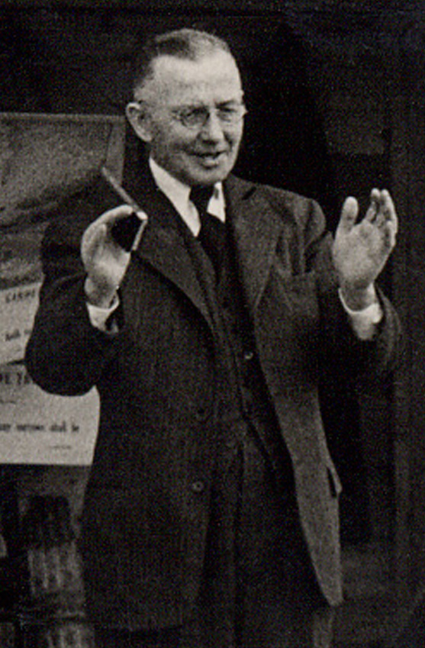
As an evangelist, Merriweather was never on holiday. "What memories flood the mind at the mention of each of these Countries! Memories of battles fought and victories won, victories that were won oft-times only after prayer and fasting. Memories in the home lands of churches visited, large and small, where young lives responded to the claims of Christ. Of homes, where I met many of the cream of the Christian Church, and some where I had the joy of leading members of the family to the Lord. Memories of sacrificial giving so that others in India might have the Gospel, which almost made me weep. Memories of groups of faithful praying men and women , mighty in faith, who have stood behind us and whose faith has been an inspiration and a benediction".

Mrs. Merriweather's tattered copy of the Book of Common Prayer and Psalms is a documentation, till now necessarily private, of God's gracious dealings with them as a family over many years, and of their great faith in Him. For example, Psalm 9, verse 10 reads, "And they that know Thy Name will put their trust in Thee, for Thou, Lord, hast never failed them that seek thee". The whole verse is underlined, the word "never" is circled, and in the margin are these words in pencil, "Bill has his£15 intact for M.T.C. March 1930", and, "When we were at wits' end corner £10 came in from Miss McGill's legatees. 1st February 1938". Against Psalm 25, verse 22, "Deliver Israel, 0 God, out of all his troubles", is this, "Praise the Lord, He has every bill paid at March 1937, and yet no allowances for January/ Feb".
During the Blitz in London, while living in Woodford, she wrote against Psalm 57 verse 1, "God's answer to prayer in enabling me to sleep last night. October, 1940". In days of great financial difficulty for the Mission as a whole, followed by the dangers of war and family bereavement, another underlined series of verses sums up their experience: "Blessed is the man whom Thou chastenest, 0 Lord...that Thou mayest give him patience in the time of adversity...for the Lord will not fail His people, neither will He forsake His inheritance...in the multitude of the sorrows that I had in my heart, Thy comforts have refreshed my soul" (Psalm 94, verses 12, 14, 19).
Merriweather returned to India as Field Superintendent, and in late 1947, after 39 years service, they retired from C.I.G.M. But not from Christ's service! The Merriweathers moved to Kotagiri in the beautiful Nilgiri Hills and soon were asked to take on the pastorate of the Evangelical Union Church there. Probably they never thought the appointment would last 25 years! This was an English-language church attended by some remarkable people. Apart from missionaries of many Protestant denominations coming up for the hot season, there were visitors from the Philippines (a grateful letter is preserved from a couple there), Malaysia, Ceylon and Pakistan. The missionaries were from Denmark, Germany, Switzerland, as well as British and American citizens, Australians and New Zealanders.
Merriweather often had them to speak in the services. But for some of his congregation, such as two girls from Mizoram, North-East India, there was a distinct sense of disappointment when someone else stepped into the pulpit. Wrote Chumi, just before she left for further education in the U.S.A.:
"Do you know, whenever I sit in the Union Hall to listen to you give your children's talk and conclude with a plea that they would give their hearts to the Lord, I keep reminding myself to tell you something - but I never get round to it. I think it was about twelve years ago now, when I was seven years old, that on January 1st, after the sermon, I went home and after thinking about it as seriously as possible all day, knelt down before going to bed, and in all earnestness gave my heart and everything I had to God, praying that he would guide me in all I did throughout my life.
"Miss Clark wanted me to tell you about it - but I was far too shy to do so. However now you know, and you can know that whatever it was you said on that Sunday twelve years ago, you moved at least one childish heart, and I do want to thank you. My love to your wonderful wife".
The Miss Clark referred to was one of a pair of English ladies of the most intrepid type, who after pioneering for 35 years in the Lushai Hills of Mizoram, and seeing a church built from head-hunting hill tribes, had retired to Kotagiri. They had brought with them several orphan girls, one of whom was Chumi.
In 1969, Merriweather wrote, "In January I had my 85th birthday, and (don't tell anybody) I was grumbling - wasn't there a retiring age somewhere when one could be free from all responsibilities, etc? I read through the Bible yearly starting at Genesis and had just got into the 14th chapter of Joshua and there underlined in red ink stood out, 'And now lo, I am this day four score and five years old... Now therefore, give me this mountain'; and I turned to see if there was anything more comforting and there on the next page underlined was 'and Caleb (at 85) drove thence the three sons of Anak (the giants)'. So pray that like Caleb we might wholly follow the Lord and see Him in our old age helping us to drive out the giants and possess all our possessions".
Both the Merriweathers indeed took every opportunity to serve the Lord in old age. Mrs. Merriweather wrote a tract in her 92nd year, just after the Six-Day War, titled "The Overwhelming Minority - Who helped Israel?" And it was through a mutual acquaintance with Lady Gregory that they got to know Mrs. Patricia Rasterick of Trichonopoly, wife of an Irish railway executive. She became a believer and was soon writing to them about her attempts to interest her husband in the Gospel.
It was not only at Kotagiri they were active, either. their plan in going there had been to pay short visits annually to their old stations in the Tamil districts of C.I.G.M. Here again they saw much blessing. Let Merriweather tell in his own words the story of Paul Asari:
‘Are you a Christian?' The man standing on the verandah was startled by the question for it was soon revealed he was one of India's 'holy' men who had sought to earn salvation by works and penances, without finding.
"My wife and I were paying our annual visit to the plains in the cool weather, and a father who had brought his daughter back to the Boarding Home after the Christmas holidays had come on to the verandah to say good-bye to Miss Casley and Miss Archer ere he took his two boys on the fourteen miles to the Boys' Boarding Home.
"Not knowing who the visitor was I had asked him the above question and got the reply, 'No, I'm a Hindu'. I found him a very interested Hindu and asked him to be seated. Ere long he was asking most intelligent questions about the way of salvation and it soon became evident that he was under conviction of sin. While we were talking I saw John, a Hindu priest I had had the joy of leading to Christ a few years previously, coming in. He sat down with us and I asked him to tell our Hindu friend what Christ had done for him. John told of his life in Hinduism with all its frustration and how one day he had taken Christ as his Saviour and how his life had been revolutionized by that choice.
"By the time John had finished it was very evident that our friend was strangely moved, and when eventually I asked him if he would like to accept Christ as his personal Saviour he said he would, and soon the three of us were kneeling together as the Hindu prayed and asked the Lord to come into his heart and save him. After he had prayed he continued for some time with eyes closed and hands clasped in the attitude of worship. When he arose I asked him where the Lord Jesus was? He replied 'He's in my heart'. Once again we had witnessed the amazing miracle of conversion".
Here, Merriweather was only reaping where others had sown. Years before, even after his child had been healed of a serious illness through the prayers of a Christian in his village, Asari had reacted with the violence of a convicted man when the Gospel was preached to him. The sudden death of his wife and the need to place his children in the Christian Homes, again brought him near. On that very day, one of his sons had said to him, "What's this, Dad, we are all going to Heaven and you to Hell?"
On his return to his home in the hills, Asari broke all his idols and was baptized, taking the name Paul. He began travelling throughout Tamil Nadu, witnessing to others, and being used in several conversions. After four years he died, still serving Christ.
On another occasion towards the end of his pastorate, visiting Bangalore on holiday, Merriweather met a man called Moses whom he had known before, and later went to his house, where he met the man's twelve year-old son. After conversation he led the boy in a prayer for salvation. That was the fourth generation of one family to whom he had ministered!
Geraldine Merriweather died peacefully in September 1974, only three months or so short of her hundredth birthday. Her son Cody tells how he remarked to her on a visit that year that she would receive a telegram from the Queen on her next birthday. Her immediate response was, "I would rather see my King Whom I have served and hear His 'well done-. No wonder that among their sons and grand-children are active church members and workers for the Kingdom of God. Their second son Bill was for some years a missionary in Papua, and a nephew, Dr. Alfred Merriweather, served with the Church of Scotland Mission in Botswana.
Merriweather himself passed away in his sleep at Brooklands Missionary Home, Coonoor, on 15th September 1977. Let us close our account with extracts from an article written by colleague Mary McDonald about his memorial service:
"Sitting in the Church, waiting for the service to begin, one was reminded of Mr. Merriweather's wide interests outside the Mission and the Union Church, Kotagiri. Hebron School, of which he was for many years chairman of council, was well represented; so was the committee which runs the Missionary Guest House - he had been chairman of that too. Many a tired or discouraged missionary coming up to the hills for a rest received counsel, and cheer, and courage to go on, from a visit to him. A beautiful wreath told of the love felt for him by the staff of the Kotagiri Missionary Fellowship Hospital. On more than one occasion Mr. Merriweather and also Mrs. Merriweather had been cared for in that hospital, and he had been chairman of that committee as well. John the Merriweathers' cook for a number of years, and 'Tumbi' their gardener were also there, as were many local non-Christian friends. Perhaps most striking of all was the presence of three tall Franciscan friars, probably young men to whom Mr. Merriweather had preached Christ (as he did to everyone he met) by the roadside or at the post office when he was posting his letters.
"The service was taken by Mr. Bruce Sinclair, and the note of triumph never faltered either in the Church or at the grave-side. After prayer we sang the hymn that many of us associate more than any other with Mr. Merriweather:

'Ten thousand thanks to Jesus
Whose life our ransom paid
Whose blood a full atonement
For all the world has made...'

1 Corinthians 15 was read first in English and then in Tamil by Pastor Gurubatham who is at present pastor at Gobichettipalyam.

As we stood by the graveside we were challenged afresh to serve our generation as Mr. Merriweather served his. We shall not see his like again. It was the end of an era."

